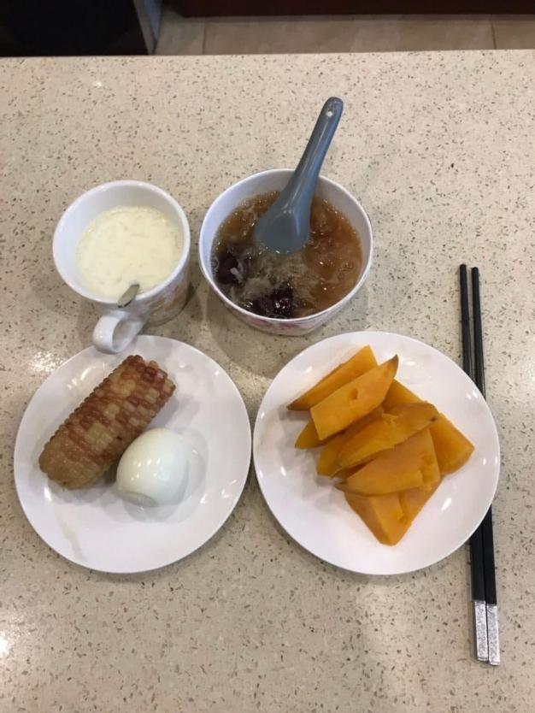

这是我的早餐，你的早餐通常会吃什么呢

This is my breakfast. What do you usually have for breakfast

这是我自己亲手下厨的早餐，希望你有美好的一天

This is my breakfast cooked by myself. I hope you have a good day



香港是一个生活节奏比较快的城市，我准备去看看新房的装修进度，下午还将和我的老师一起去打高尔夫

Hong Kong is a city with a fast pace of life. I'm going to see the progress of the renovation of the new house, and I will play golf with my teacher in the afternoon.

过个30-45分钟，这个时间可以根据客户的回复来决定不做限制

司机来接我了

The driver to pick me up

（间隔30分钟）

早上香港的交通堵塞非常严重。我已经到目的地了

The traffic jam is very serious in Hong Kong in the morning. I have already arrived at the house

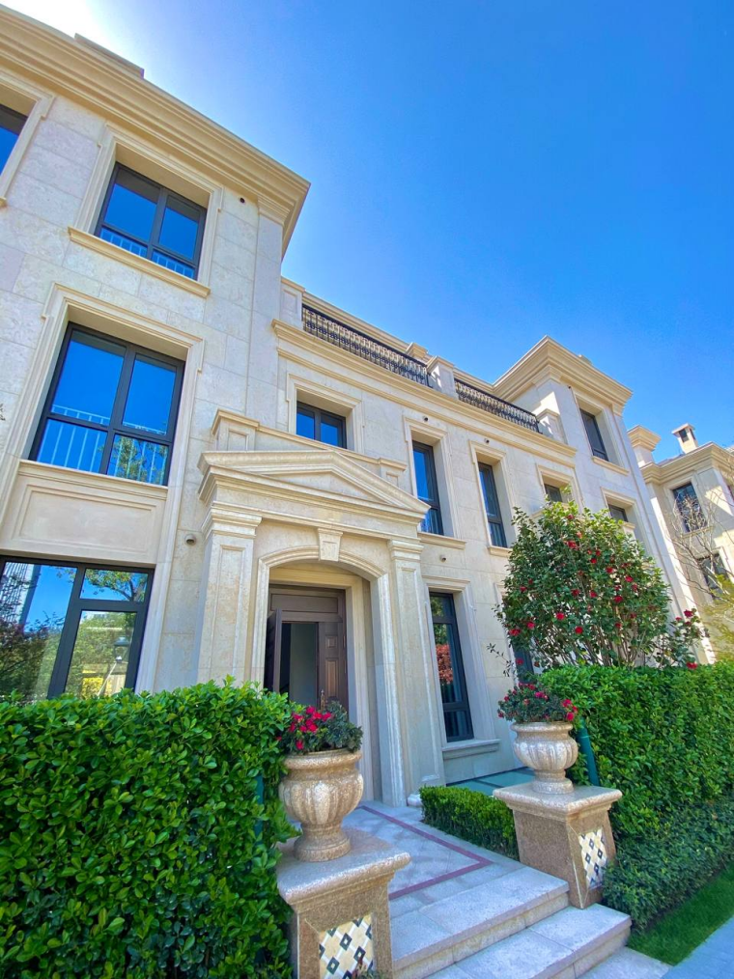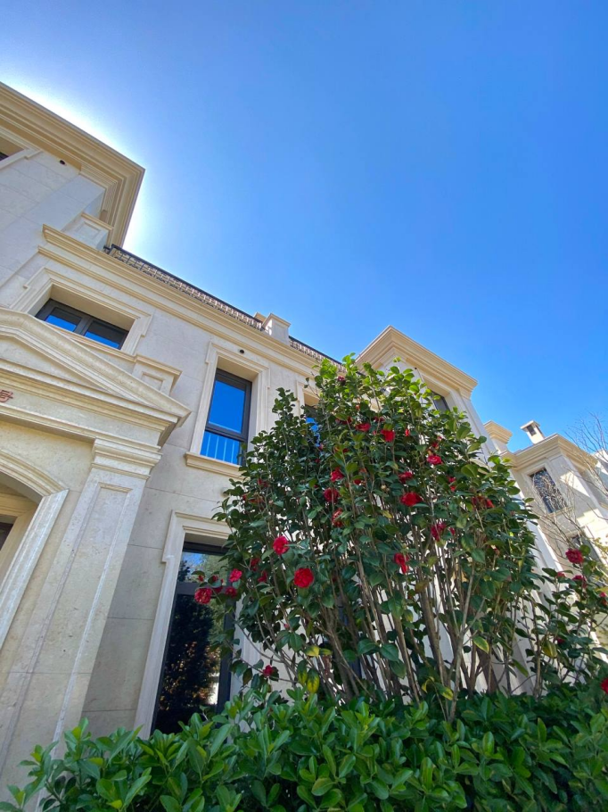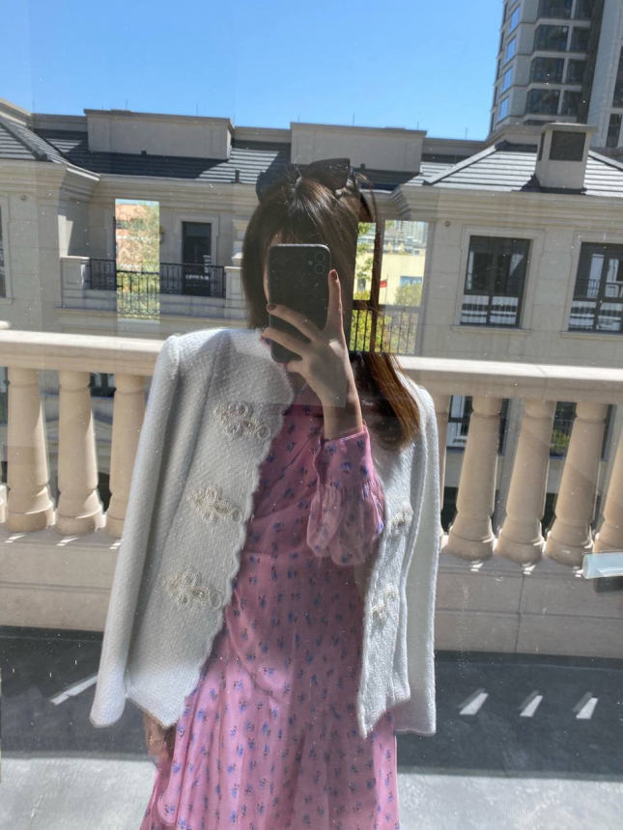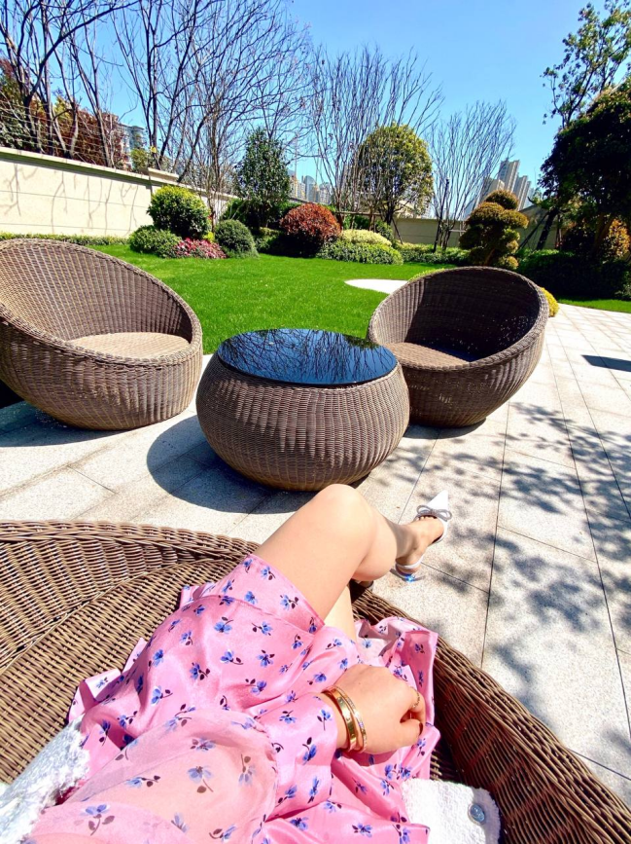

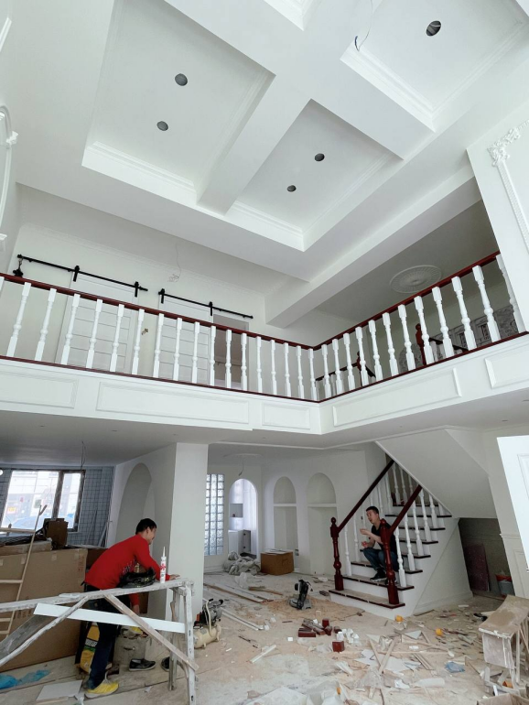

客厅仍在装修，所有房间都用可回收材料装饰，倡导环保

The bathroom is still being decorated, but the living room has been decorated, all of which are decorated with recyclable materials, and environmental protection is advocated

香港的房价特别高。这个185平方米的学区房间每平方米的成本为13，000美元，这花费了我240万美元！不过，最近加密货币市场一直不错，投资回报率只有房价的三分之一。

The rooms in Hong Kong are particularly high. This 185 square meter school district room costs 13,000 US dollars per square meter, which cost me 2.4 million US dollars! However, the foreign exchange market has been good recently, with an investment return of one-third of the house price.

这一切都要感谢我的老师，我的老师教会我投资，也是我投资的启蒙老师

All this is thanks to my teacher, who taught me to invest and is also the first teacher of my investment

包装老师 （借鉴话术）

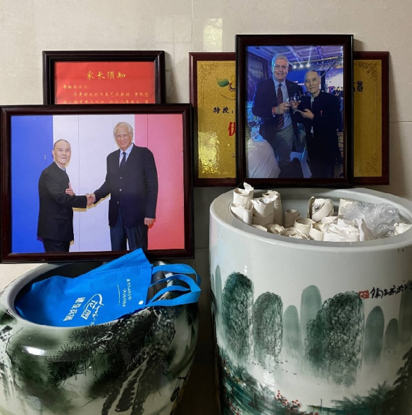

和你聊天我觉得很亲切很开心。像久违的老朋友。我希望我们能一直保持这种友谊。

I feel very kind and happy to chat with you. Like a long-lost old friend. I hope we can keep this friendship all the time.

我有一个好主意。为了加深我们的友谊，我应该给你一个中文名字。你喜欢什么样的名字？

I have a good idea. I should give you a Chinese name to deepen our friendship. What kind of name do you like?

我的中文名字叫李玉，你的名字是李杰 。你觉得这个名字怎么样?

My Chinese name is Li Yu and your name is Li Jie . What do you think of this name?

李玉含义：意志坚定，事业较稳定，一帆风顺，财源广进，积极向上的生活态度。

Li Yu meaning: strong willed, stable career, smooth sailing, prosperous, extremely upbeat attitude to life

李杰的意思。 有绅士风度。前途一片光明。 事业稳定。 财富在增长。 幸福和快乐相伴。 心中的愿望和梦想。 一一的实现。

Meaning of Lee J. There is gentlemanliness. A bright future. Career is stable. Wealth is growing. Happiness and pleasure go hand in hand. Wishes and dreams in your heart. One by one, they are

coming true.

直接发送视频给客户

你喜欢这个名字吗？

Do you like this name?

起名字我们主要的目的就是为了加深和客户的感情，为接下来的二切做好足够的热度，起名字后我们以后叫客户就叫客户李杰了，这个要记住，别自己起的名字自己给忘记了

下午来上班的时候发给客户

李杰我要准备一下和老师打高尔夫球的运动设备。劳逸结合可以使我的生活更好。除了投资，健身也是我的爱好之一 。

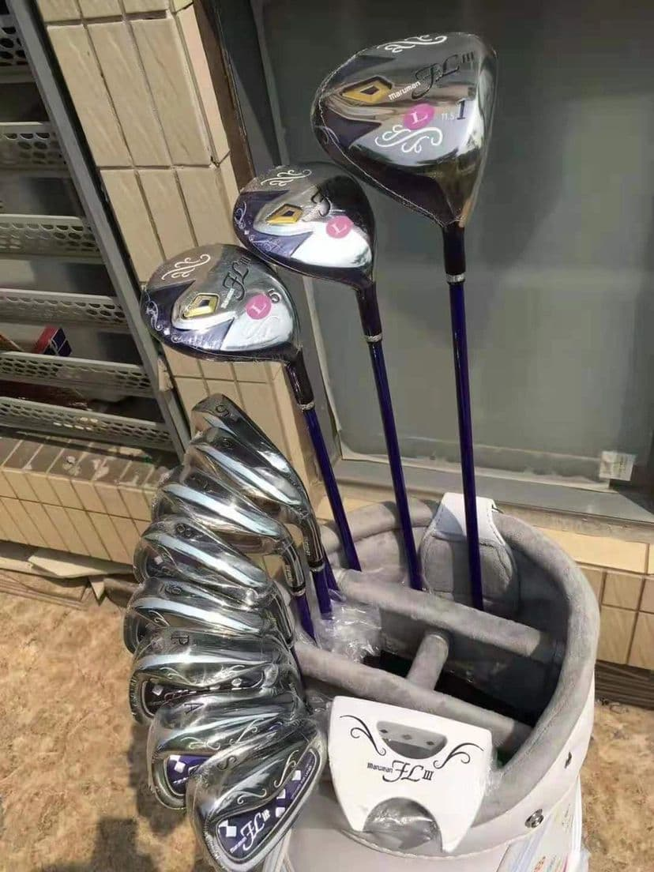

这是香港浅水湾高尔夫球场。天气很好。球场非常美丽。会使人心情愉悦

This is Hong Kong's Repulse Bay Golf Course very beautiful. weather is good. The beautiful view puts a good mood

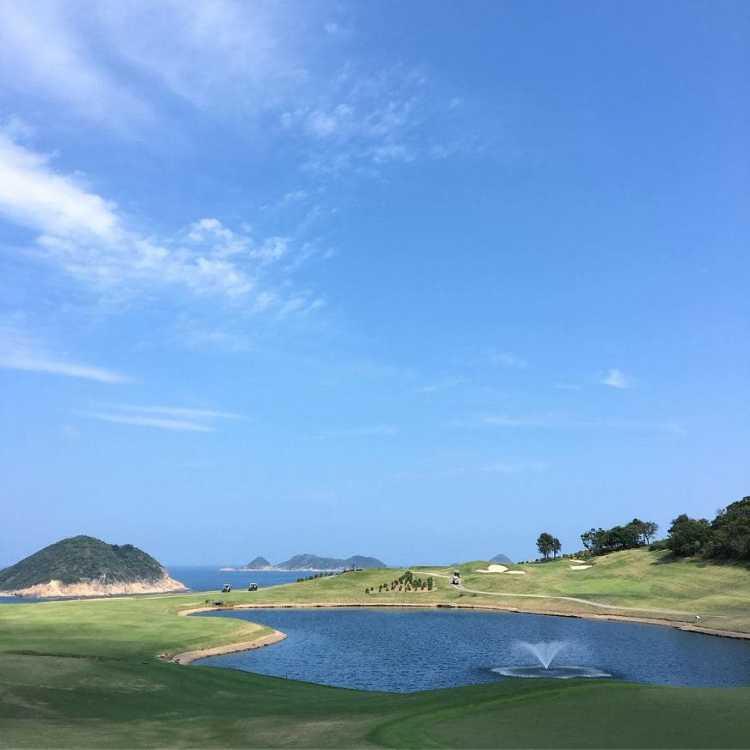

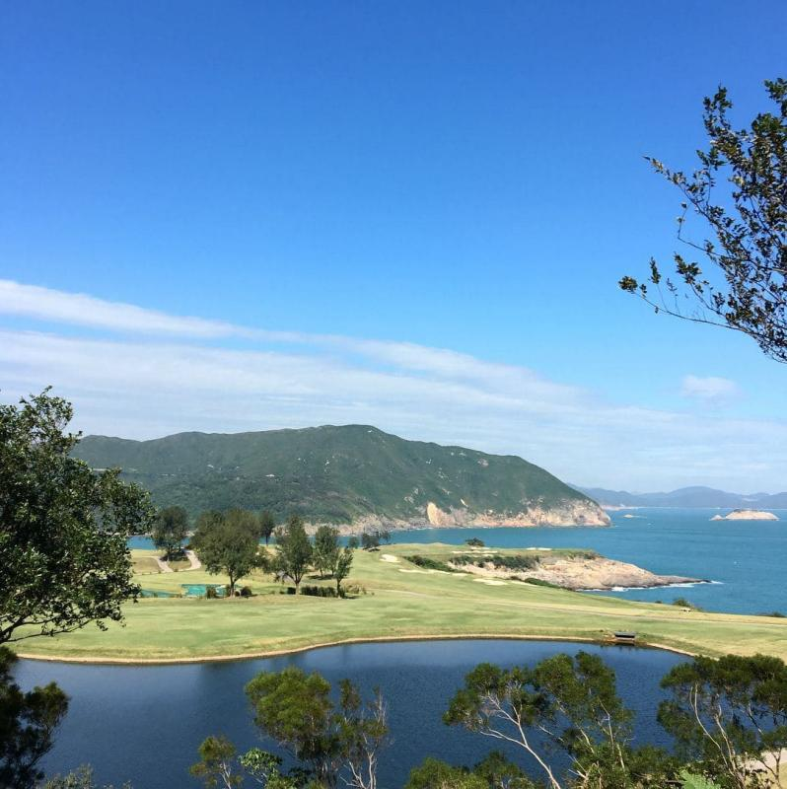

高尔夫照片视频，我到时候会根据香港的天气来给你发！

谢谢你昨天借给我的好运，我今天赢了我的老师，我好开心

Thank you for the good luck you lent me yesterday. I beat my teacher today. I am so happy.

我决定过段时间再拜访老师，老师告诉我明天是加密货币的狂欢节，各国的货币数量统计将会造成剧烈的波动，让我把握收益，预计在百分之40。

I decided to visit my teacher again after a period of time. The teacher told me that tomorrow will be a carnival of foreign exchange. The statistics of the amount of money in various countries will cause drastic fluctuations. Let me grasp the revenue, which is expected to be 40%.

我们晚上聊

我结束了劳累的一天，到家了，今天赢了老师，我好开心，我很久没有这么开心了

I got home after a hard day. I beat my teacher today. I am so happy. I haven't been so happy for a long time.



开始走心话术讲故事（卖惨，越惨明天的机会越大，努力去挖掘客户内心不开心的事情和悲伤的事情，如果客户也会和你倾诉，那这个走心就成功了）

我曾经经历过一次失败的婚姻，让我迷失了很长一段时间不能从感情的阴影中走出来

I once experienced a failed marriage, which made me lost for a long time and couldn't get out of the shadow of my feelings

在我26岁的那一年，因为创业，没有时间陪伴他，他选择了背叛我们的婚姻，丢弃一个做父亲的责任

When I was 26 years old, because I started a business and had no time to accompany him, he chose to betray our marriage and abandon the responsibility of being a father

他说自己去大陆出差，结果居然是去和他的女友约会，我突然一天接到他手机一个陌生女人的电话，我才知道了真相，不然我一直都在被他欺骗

He said that he was going to the mainland on a business trip and the result was to go on a date with his girlfriend. I suddenly received a phone call from a strange woman on his cell phone one day, and then I knew the truth. Otherwise, I had been cheated by him all the time.

从那以后，我一直都是一个人。因为我认为和不正确的人在一起这并不能让我摆脱孤独，它反而会加快我自己的消耗！

Since then, I have been alone. Because I think being with the wrong people doesn't make me get rid of loneliness, but it will speed up my own consumption

我是一个非常重视感情的人。 我经历了感情的背叛，所以我现在简直不敢相信一个人。

I am a person who pays great attention to feelings. I have experienced the betrayal of feelings, so I can hardly believe in one person now.

Can you understand?

你能明白吗？

你是我能倾诉的为数不多的异性之一。我想这可能是缘分吧。总觉得有很多话题可以和你聊。

You are one of the few opposite sex I can talk to. I think this may be fate. I always feel that there are many topics to talk with you.

走心后节奏要控制好，可以说去洗手间洗把脸，流下了很多眼泪等等，然后拉进关系的话术多使用，最后包装一波行情：不好意思，我刚刚去看分析师的行情通知（给客户甩行情包装图） 谢谢你李杰，你像绅士一样的照顾我，陪伴我，我很感激，你也给我带来了幸运，希望我们可以一起保持我们这样的关系！

明天的交易时间很早，我需要早点休息，不然明天睡懒觉就会错过行情了，加密货币市场行情每一次都是珍贵的！

